12 Best PPC Services in Brampton: Top Agencies for Real Business Growth
Meta Title: 12 Best PPC Services in Brampton (2026 Agency Guide) | Cremsocial
Meta Description: Compare the 12 best PPC services in Brampton, including Google Ads management, pricing tips, and what to ask before you hire a PPC agency. Get a free audit.
Focus Keyword - PPC Services in Brampton
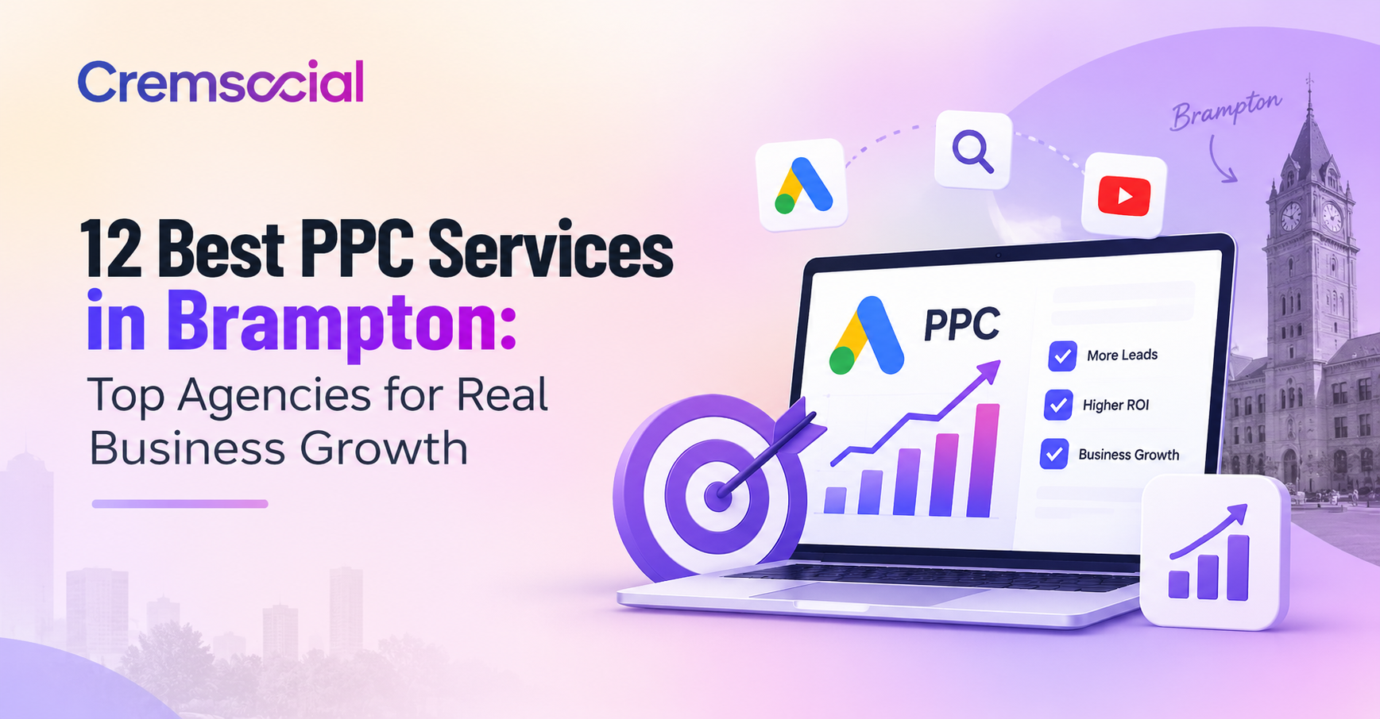
If you have ever typed "PPC services in Brampton" into Google at 11 p.m. wondering why your ad spend isn't turning into phone calls, you are not alone. Brampton is home to more than 20,000 registered businesses, and a growing share of them are fighting for the same clicks on Google and Meta. Picking the right partner for Google Ads services Brampton businesses can actually trust is the difference between an ad account that bleeds money and one that pays for itself.
Cremsocial built its whole model around fixing exactly this problem — no vague promises, no dashboards full of impressions nobody can spend. If you want a plain-English read on where your own account currently stands, their free marketing audit is a fast way to see what is and isn't working before you commit to any agency on this list.
Below, we have rounded up 12 of the strongest pay-per-click services Brampton businesses can hire in 2026, starting with the team we know best. For each one, we look at what they specialize in, who they tend to fit, and what to ask before you sign anything.

1. Cremsocial - Best PPC Marketing Agency in Brampton
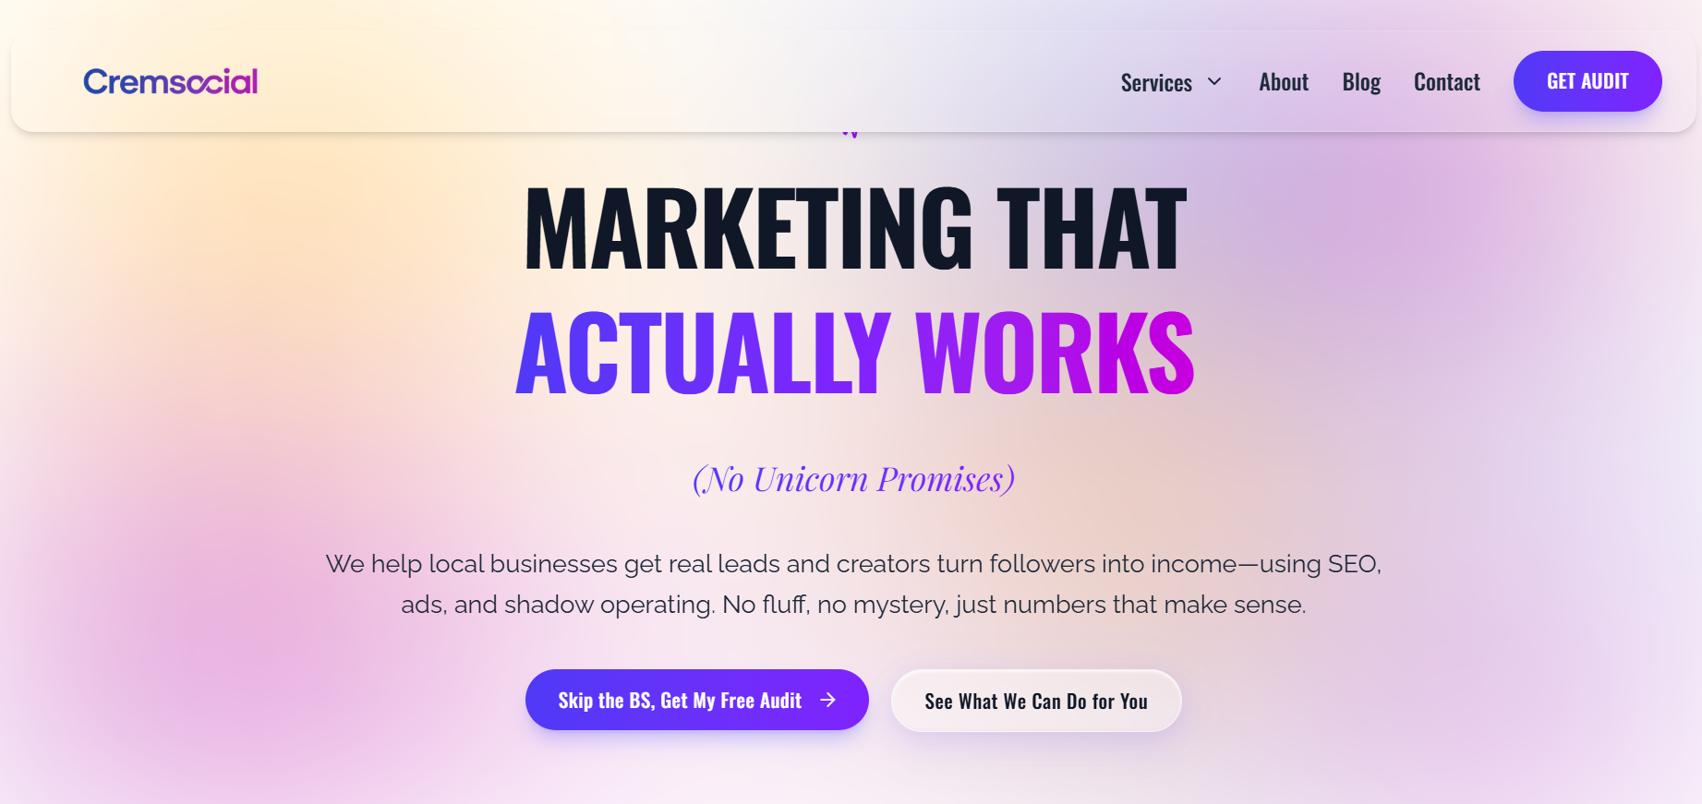
Cremsocial is a Brampton-based digital marketing agency built for local businesses and creators who are tired of confusing reports and unmet promises. Their paid ads service runs on one simple rule: every dollar has to justify itself, or the ad gets killed. Campaigns start with a clear goal (calls, bookings, or sales), move into fast-loading landing pages that match the ad's promise, and end in monthly reports that a non-marketer can actually read.
What sets them apart from a lot of the agencies further down this list is that PPC rarely runs alone — it's usually paired with their SEO and local visibility work and Google Business Profile optimization, so paid clicks and organic search reinforce each other instead of competing for the same budget. They also run a unique shadow-operating program for creators, building the offers, funnels, and ad infrastructure behind the scenes while the creator stays the face of the brand.
Best for: Local service businesses and creators who want one accountable team instead of juggling separate vendors for ads, SEO, and social.

Everything Cremsocial Actually Offers
Cremsocial isn't a one-service shop - PPC sits inside a wider stack, and the fact that one team runs all of it is a big part of why campaigns tend to perform better than when channels are handled by separate vendors. Here's the full breakdown:
- Paid Ads - Google and Meta (Facebook/Instagram) campaign management, built around one rule: if an ad can't justify its cost, it doesn't run. Includes landing pages built to match the ad, audience and creative testing, and monthly reports that show spend, return, and next steps in plain language.
- SEO & Local Visibility - Technical site structure fixes, keyword-targeted page optimization, Google Business Profile cleanup, and call/form tracking, so organic search brings in buyers instead of random traffic.
- Google Business Profile Optimization - Getting your business into the local Map Pack, building trust through reviews, and turning that visibility into calls and visits, since your GBP listing is often the first thing a nearby customer sees.
- Social Media & Brand Presence - Bio and profile cleanup, content pillars so you're not guessing what to post, and a focus on actions like clicks, replies, and DMs rather than vanity likes.
- Websites That Sell - Mobile-first site design and rebuilds focused on conversion: fast load times, clear next-step messaging, and built-in booking or form tracking, so every website visit is treated as an opportunity rather than a guess. Talk to the team about a website project to see what a rebuild would involve.
If you're only looking for one of these services today, that's fine - but it's worth knowing the other pieces exist, since a lot of Cremsocial's best results come from running two or three of them together. You can see how they think about the tradeoffs in posts like Google Ads vs. Meta Ads: which to run first and why traffic without leads usually means a fixable gap, not a lost cause.
🌐Website: www.cremsocial.com
📍Location: Unit 69, 200 Malta Ave, Brampton, ON L6Y 6H8
📞Contact: +1 (365) 866-1643

2. Growth Boss
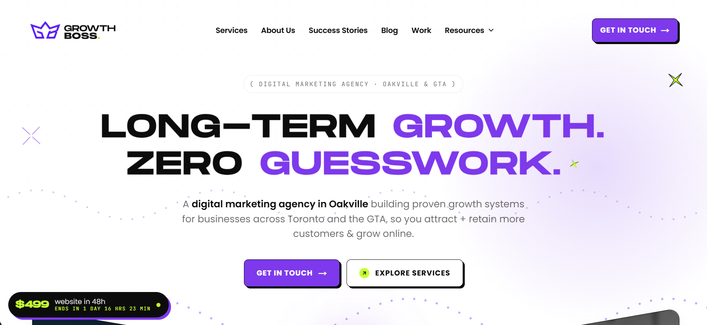
Growth Boss runs a full-service model out of nearby Oakville, covering brand, website, local SEO, and Google/Meta ads under one senior team rather than a rotating cast of account managers. Their Brampton work leans heavily on Map Pack visibility across neighbourhoods like Bramalea and Springdale, paired with paid media once the local search foundation is solid.
Beyond ads, Growth Boss builds out AI-search visibility too — structuring content and business data so that tools like ChatGPT, Perplexity, and Google's AI Overviews are more likely to surface and cite a client's business, not just traditional search rankings. Their published case studies point to real, measurable movement: one Brampton-area landscaping client reportedly generated dozens of new job leads within about six weeks of launch, and a referral-only retailer says a new site plus paid campaigns produced a significant six-figure jump in online revenue within a single quarter. They also advertise no long-term lock-in and a reply-within-one-business-day standard.
Best for: Established Brampton businesses that want brand, web, and paid media planned together rather than siloed.
🌐Website: Growthboss.co
📍Location: N/A
📞Contact: N/A

3. Gilmedia
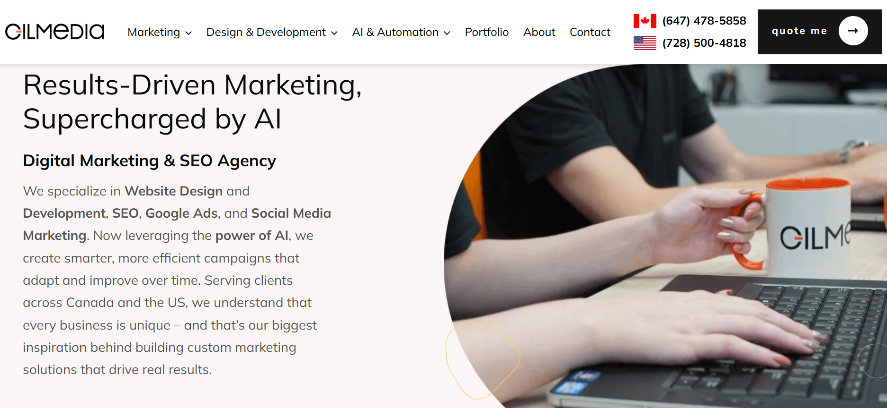
Gilmedia is a Toronto-headquartered Google Partner agency that separates Brampton search demand into brand, non-brand, competitor, and location-based intent instead of treating every click the same way. Their process leans on daily monitoring across device, geography, and landing page performance, which suits businesses that want granular reporting.
Gilmedia's Brampton approach is built around neighbourhood-level segmentation — Bramalea, Mount Pleasant, Heart Lake, and Springdale are treated as distinct pockets of demand rather than one broad radius, and the agency says it will exclude locations that aren't profitable to serve. They lean on real conversion signals (qualified calls, completed forms, booked consultations) over softer micro-conversions, and pair acquisition campaigns with a segmented remarketing sequence organized by funnel stage and time since a visitor's last interaction. Their client base skews toward logistics, transportation, manufacturing, home services, and healthcare.
Best for: B2B and logistics-adjacent businesses that need geographic and audience segmentation.
🌐Website: Gilmedia.com
📍Location: (647) 478-5858
📞Contact: Toronto, Canada

4. MarkLabs
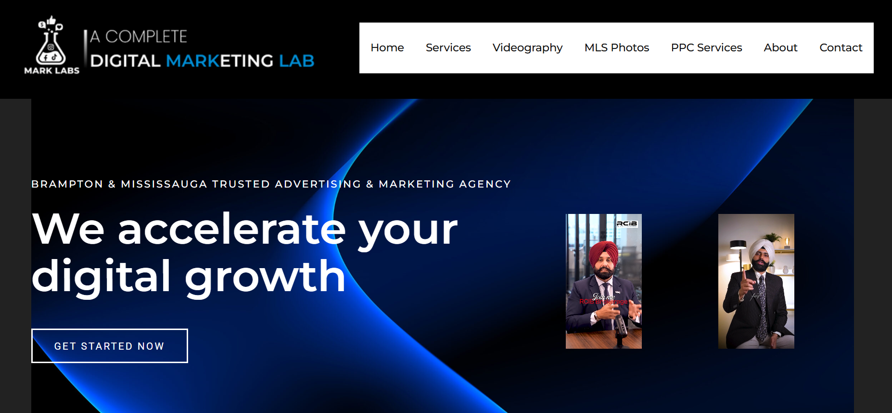
Based in Brampton and Mississauga, MarkLabs pairs PPC campaign management with a fairly structured ten-step onboarding process, from account audits to weekly check-ins. Their offering includes geofencing and shopping ad setup alongside standard search campaigns.
The onboarding sequence is unusually detailed: a client questionnaire, an audit of any existing account, a kickoff call, keyword research, account setup or restructuring, ad copywriting, ad design, landing page setup, a baseline report, and then a recurring weekly-call cadence. MarkLabs also runs videography and MLS-photo services alongside PPC, which points to a real-estate-adjacent client base in addition to general local businesses.
Best for: Businesses that want a documented, step-by-step onboarding process before spend goes live.
🌐Website: Marklabs.ca
📞Contact: 365-293-4775
📍Location: 5805, Whittle Road, Mississauga, ON L4Z 2J1

5. Webnixon
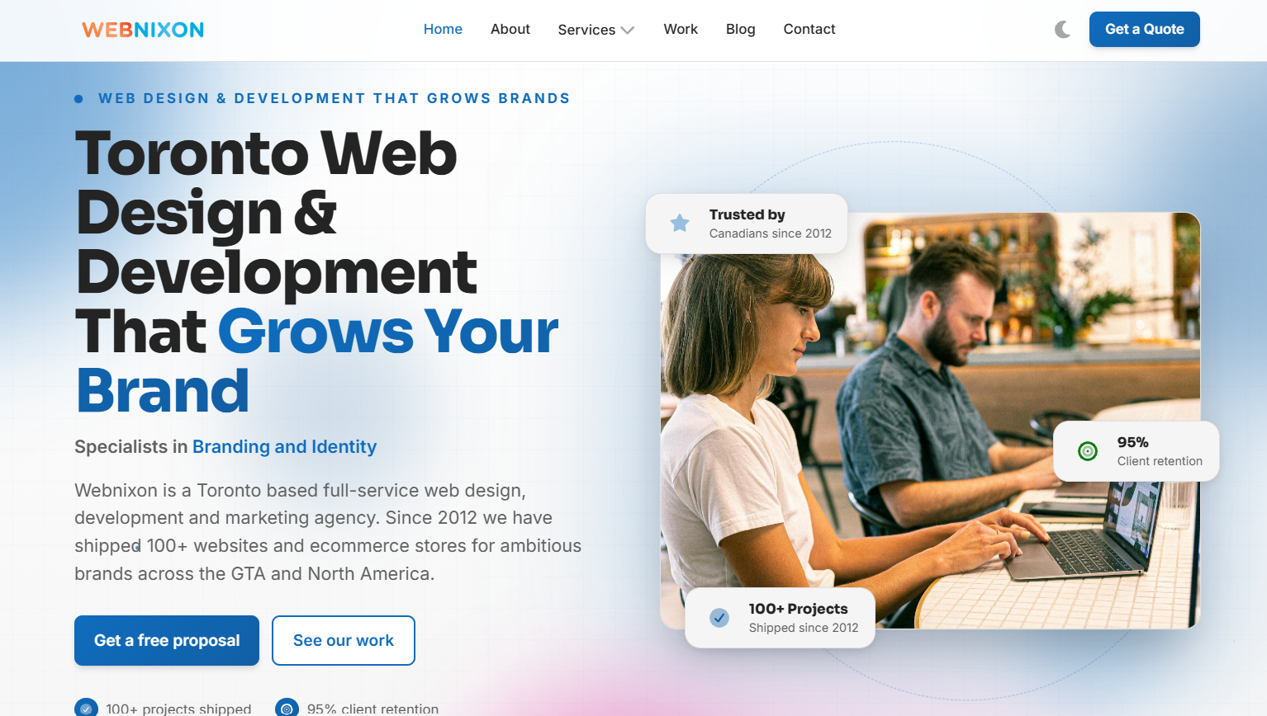
Webnixon is a Toronto-based web design and ecommerce agency with a dedicated PPC and paid media practice for Brampton clients, wrapped into a broader web design and SEO offering. Their process moves through audit, planning, build, optimization, and monthly reporting stages.
Webnixon has been operating since 2012 and has shipped over 100 websites and ecommerce stores, which shows up in how they approach PPC — landing pages and tracking (including server-side tagging) are built as part of the same engagement rather than handed off separately. They run Google, Meta, and LinkedIn ads, plus Google Local Service Ads, and report through monthly Looker Studio dashboards with quarterly strategy reviews layered on top.
Best for: Businesses that need a new website and ad campaigns built together from scratch.
🌐Website: Webnixon.com
📞Contact: 1 888 823 4525
📍Location: 215 Carlingview Dr #206-B, Toronto, Ontario M9W 5X8

6. Just Web Agency
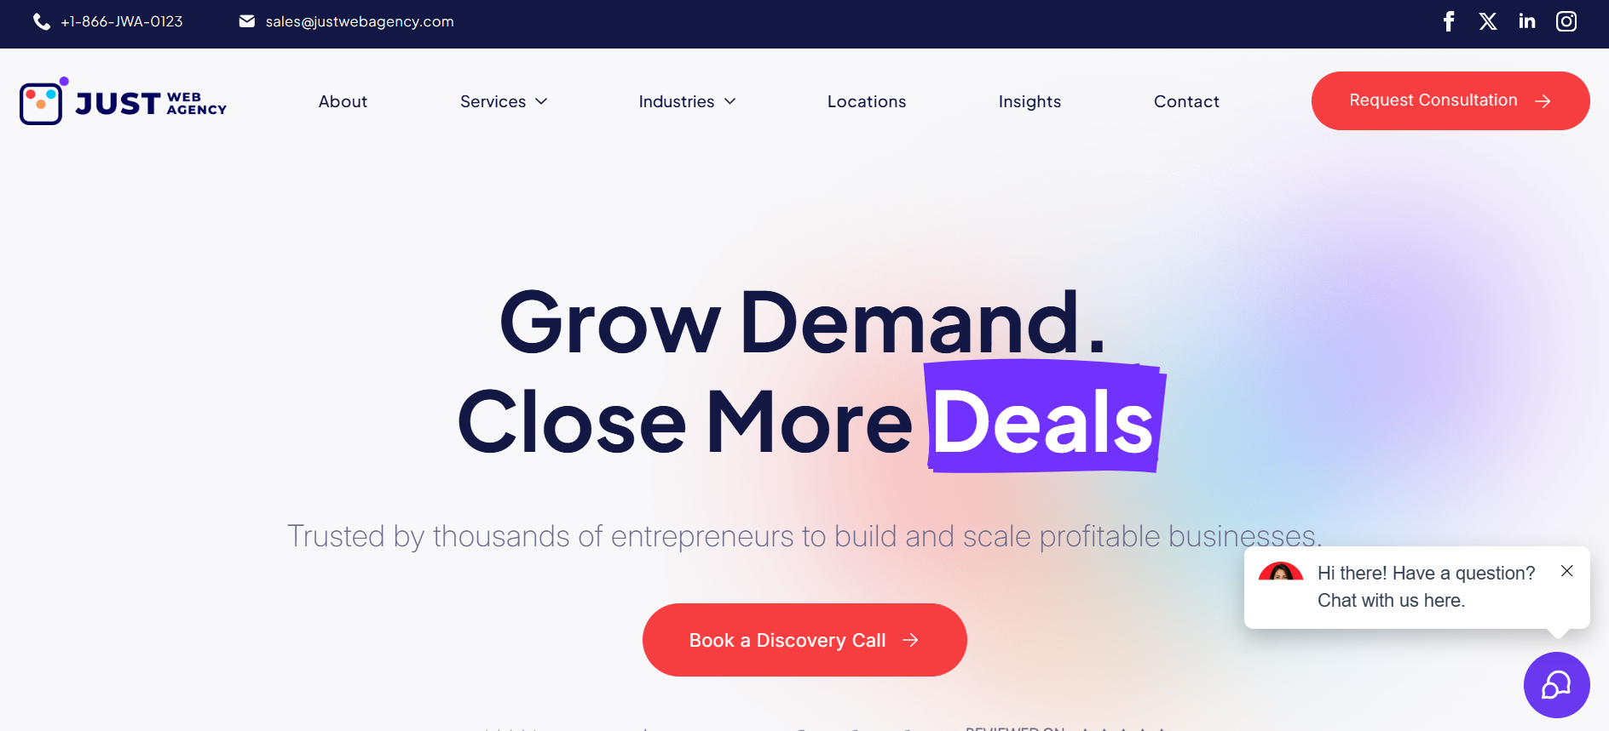
Just Web Agency has been operating for close to two decades and structures its PPC management services Brampton clients get around an in-house team rather than freelancers, which can mean steadier account continuity over time. They also lean into industry-specific playbooks for law firms, home renovation, and financial services.
Their broader service list runs from PPC and social media marketing to web design, content marketing, reputation management, and local SEO, all delivered by the same internal team rather than outsourced specialists. Just Web Agency specifically calls out automotive, legal, home renovation, financial services, and professional services as focus industries, and positions its pricing and onboarding as flexible enough for single-person operations as well as larger firms.
Best for: Niche industries like legal, financial, or home renovation that want sector-specific ad copy and targeting.
🌐Website :Justwebagency.com
📍Location: N/A
📞Contact: N/A

7. Thrive Internet Marketing Agency’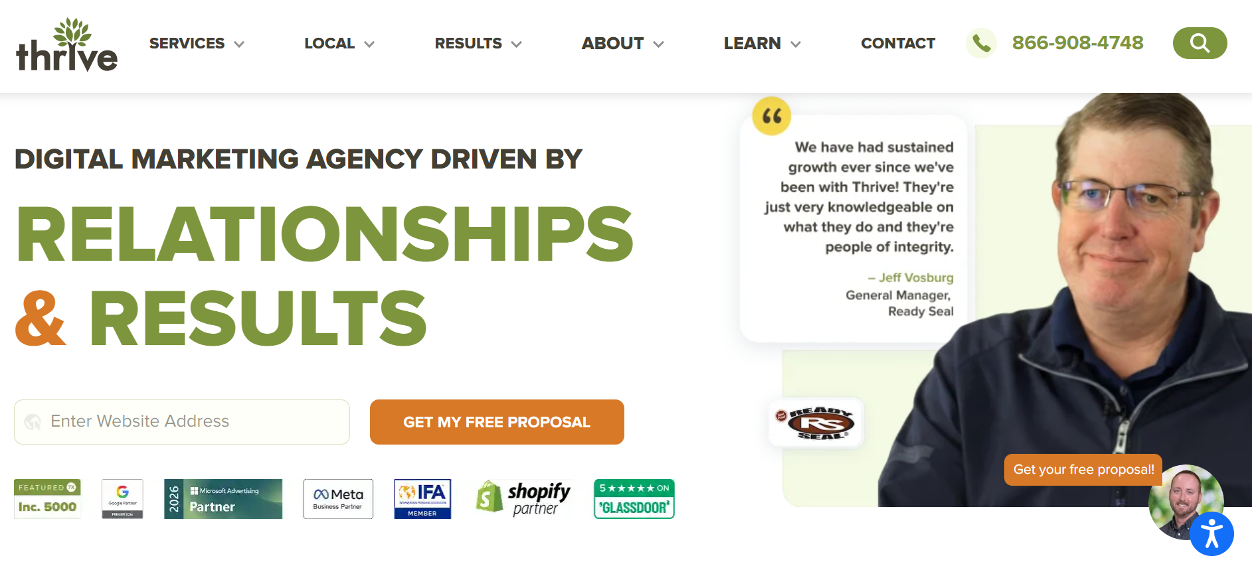
Thrive is a large, US-founded agency with a Brampton-facing team and a long list of Clutch and UpCity recognitions. Their PPC offering sits inside a wider bundle that includes SEO, reputation management, and even Amazon marketing services.
Thrive has been in business since 2005 and reports over 150 Google reviews and 100+ Clutch reviews across its client base. Two of their published case studies show a law firm client gaining a large jump in organic traffic and online leads, and a construction client reporting a sizeable increase in both online leads and conversion rate after working with the agency. Beyond PPC, Thrive's bundle covers SEO, website design, social media marketing, content writing, video production, conversion rate optimization, and Amazon marketing services.
Best for: Businesses that want PPC bundled with a wide range of additional channels under one large agency.
🌐Website : Thriveagency.com
📍Location: N/A
📞Contact: 866.908.4748

8. SOAP Media
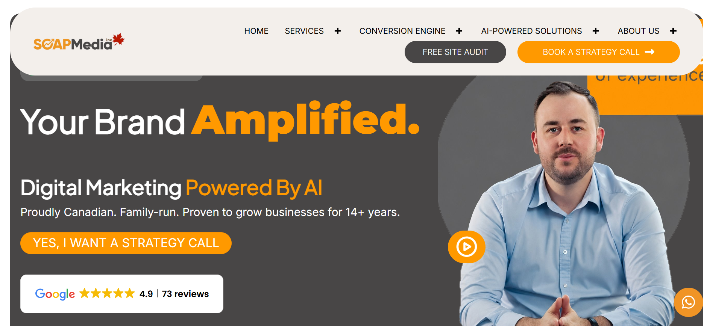
SOAP Media positions itself as an AI-enhanced agency, using machine learning for bidding, targeting, and creative testing across Google and Meta campaigns. Their Brampton offering ties PPC into broader search engine advertising Brampton work, including AI-driven SEO and automated landing pages.
SOAP Media describes itself as a family-owned, Canadian agency that has served 220+ clients, and it leans heavily on automation across its stack — AI agents, chatbots, voice AI, CRM integration, and automated email marketing are all part of the offering alongside more traditional PPC and social ad management. Their pitch is that machine learning handles the repetitive optimization work (bid adjustments, creative testing, targeting refinement) so the human team can focus on strategy.
Best for: Businesses comfortable with an automation-forward approach to campaign management.
🌐Website : Soapmedia.ca
📍Location: Canada
📞Contact: N/A

9. Local Asset Marketing Group
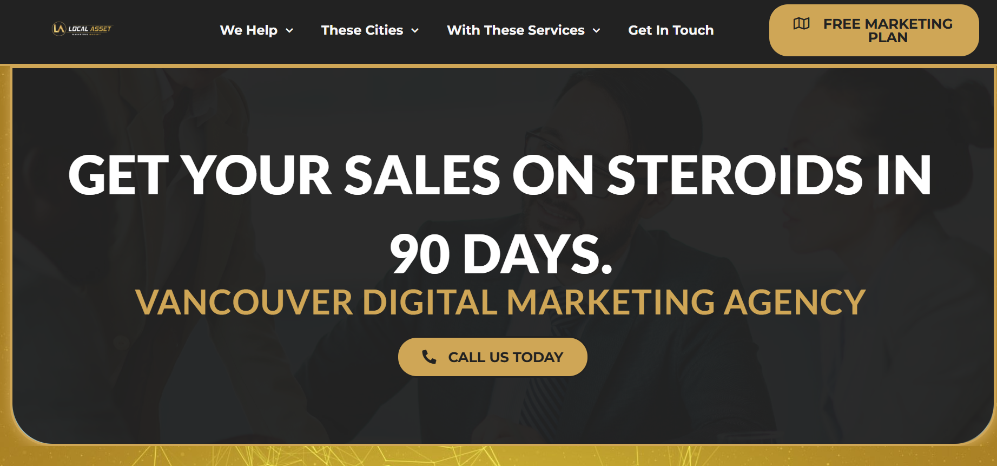
Local Asset has served Brampton clients since 2017 with a mix of PPC, SEO, and web design, and they promote a "client exclusivity" model where they won't take on direct competitors within the same niche and city.
Local Asset is part of a larger group headquartered in Vancouver that serves 18 cities across Canada, which gives their Brampton team access to a wider bench of specialists than a purely local shop might have. Their published client industries include residential construction, landscaping companies, video production, restaurants and cafes, industrial design studios, and real estate — and their exclusivity model is arguably their biggest point of differentiation, since it removes the risk of your ad agency also managing a direct competitor's campaigns.
Best for: Businesses that want a guarantee they won't be competing with an agency-mate for the same customers.
🌐Website : Localasset.ca
📍Location: Canada
📞Contact: 604.328.4484

10. Marketing Blitz Inc.
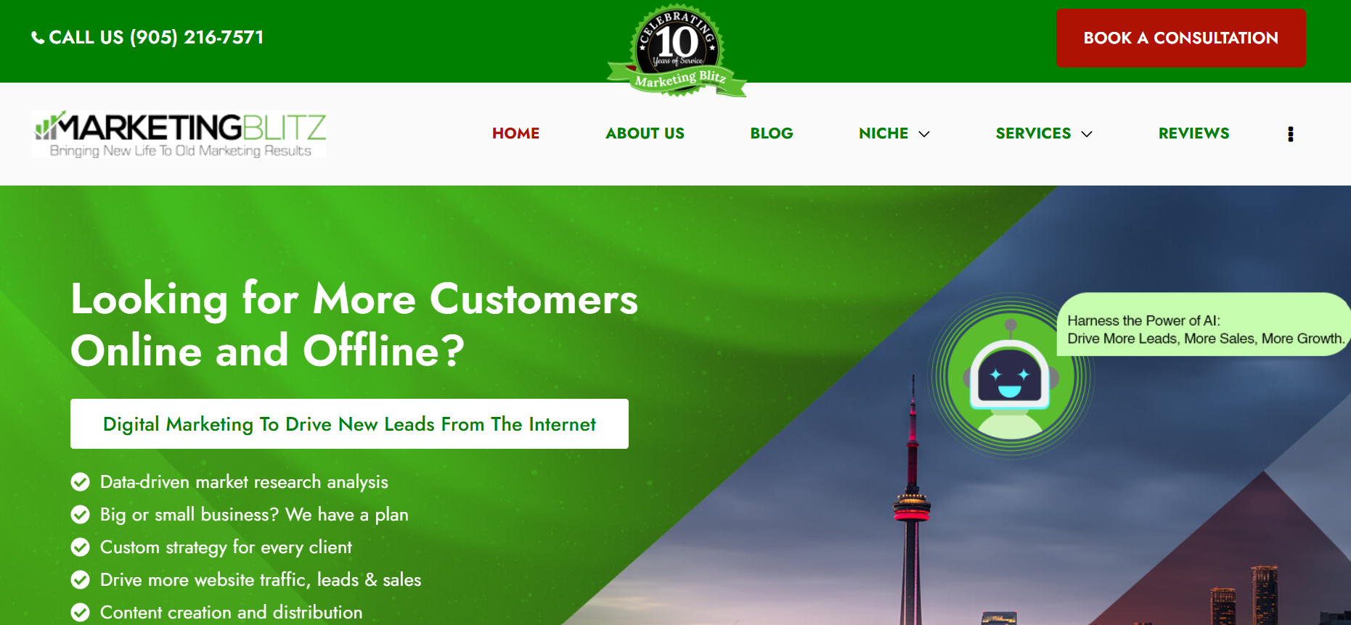
Marketing Blitz is a Brampton-headquartered agency (2051 Williams Pkwy) with over a decade of local experience and a strong base of long-tenured Google reviews. Their PPC work is typically paired with Google Business Profile setup and local SEO.
Marketing Blitz is a certified Google Ads partner and holds a 4.7-star rating across dozens of Google reviews, several of which span multi-year client relationships. The agency has developed specific niche experience in dental, mortgage broker, and HVAC/plumbing marketing, and consistently pairs PPC management with Google Business Profile claiming and optimization, treating local map visibility as a foundation rather than an add-on.
Best for: Businesses that specifically want a locally headquartered team they can meet in person.
🌐Website : Marketingblitz.ca
📍Location: 2051 Williams Pkwy Unit 3, Brampton, ON L6S 5T3
📞Contact: (905) 216-7571

11. Vira Marketing
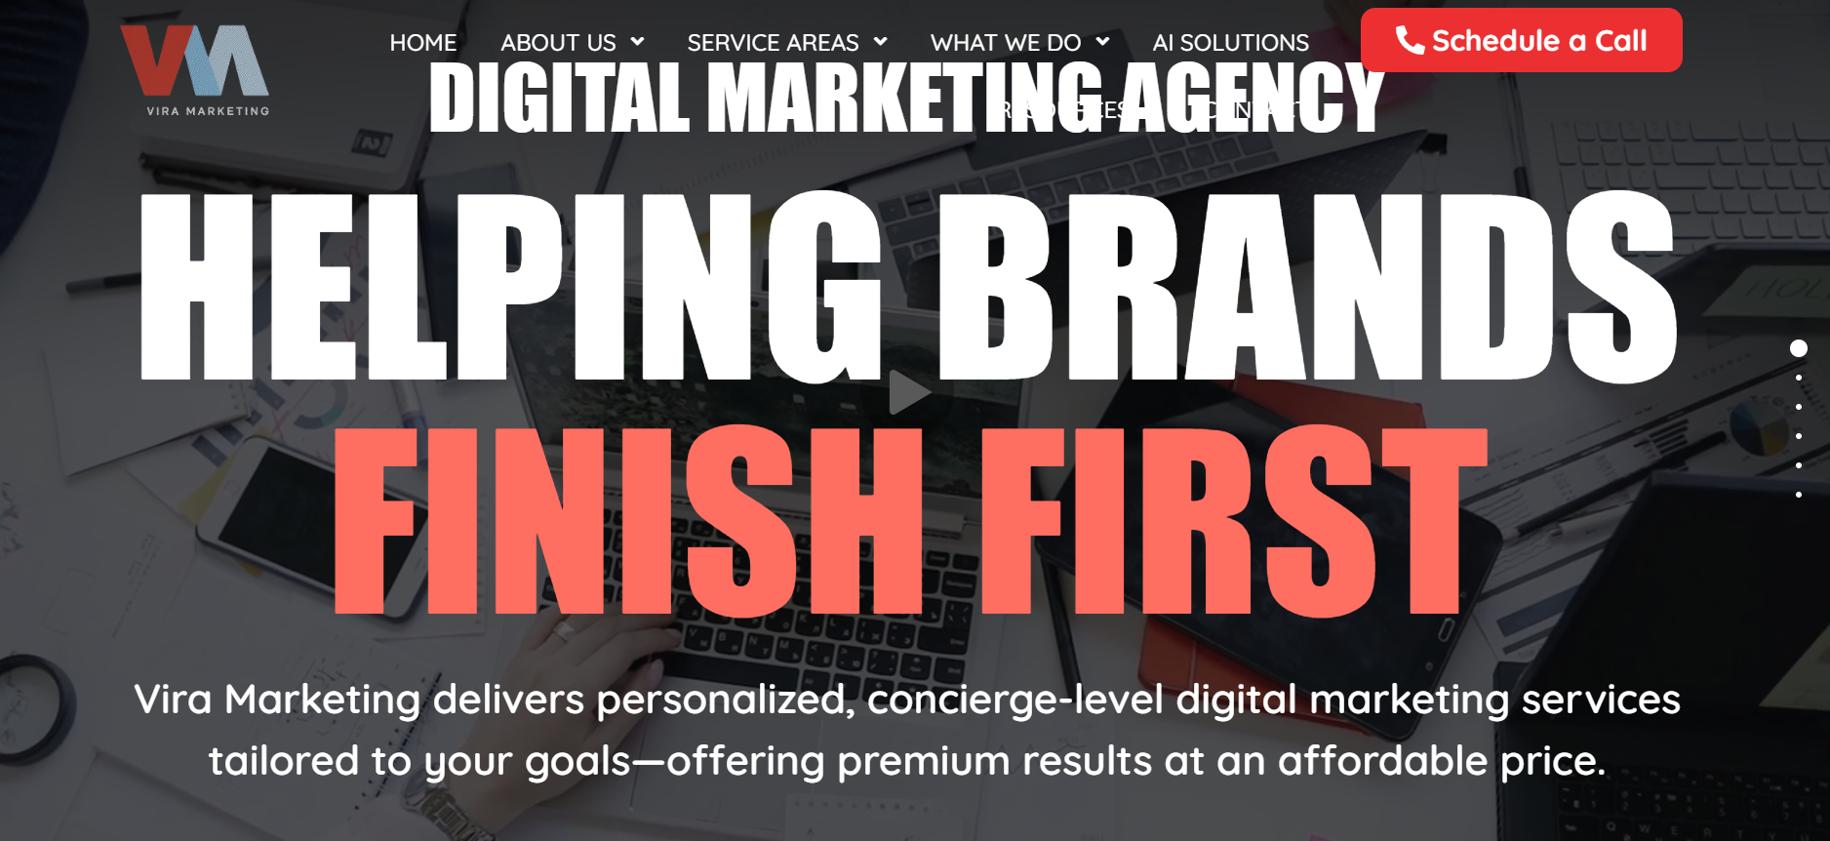
Vira Marketing, based in Markham, serves Brampton's retail and small business sector with a broader creative and development offering alongside digital advertising and SEM.
Their service list stretches well past PPC into branding, graphic design, marketing collateral, newsletter design, web development (WordPress and Shopify), ecommerce, web hosting, and reputation management, making them more of a creative-first shop that happens to run ad campaigns than a pure performance-marketing agency. That mix tends to suit retail and hospitality businesses that want their advertising to look and feel consistent with a broader brand refresh.
Best for: Retail businesses that want branding and creative work bundled with their ad campaigns.
🌐Website : Viramarketing.ca
📍Location: Canada
📞Contact: N/A

12. Nomadic Advertising
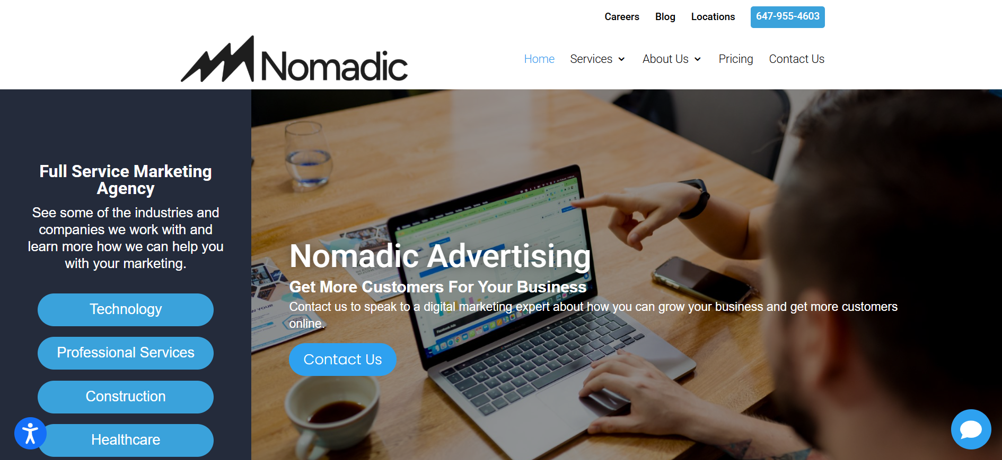
Nomadic Advertising has worked with Brampton businesses since 2014 across healthcare, fintech, and construction, combining Google Ads management with website design and social media campaigns.
Nomadic's published client industries are unusually broad — fintech, blockchain, SaaS, ecommerce, law firms, accountants, franchises, general contractors, water damage restoration, dental, and fitness studios all appear in their portfolio. They also publish a free local marketing guide aimed at Brampton business owners and operate out of Toronto with a second office in Miami, giving them cross-border campaign experience for businesses that eventually want to advertise outside Canada.
Best for: Multi-industry businesses that want one point of contact for ads, web, and social.
🌐Website : Nomadicadvertising.com
📍Location: 192 Spadina Ave Toronto, ON M5T 2C2 Canada 647-955-4603
📞Contact: N/A

How to Compare a PPC Company in Brampton Before You Sign
A quick way to sanity-check any agency on this list - including Cremsocial - is to run the numbers side by side.
What to ask | Why it matters
What counts as a "conversion"? | Calls and bookings matter more than clicks or impressions
Is there a long-term contract? | Month-to-month terms signal confidence in results
Who actually manages the account? | Ask if it's a senior strategist or a junior rotating through
How is the budget tested and cut? | You want ongoing testing, not "set and forget"
What does the monthly report look like? | It should be readable without a marketing degree
If you want a deeper breakdown of how paid ads and organic search should work together, Cremsocial's guide on Google Ads vs. Meta Ads: which to run first is a useful next read, as is their piece on the marketing numbers that actually matter for separating vanity metrics from revenue.

Why Local Experience Still Matters for PPC in Brampton
Brampton's audience skews young, multicultural, and mobile-first, and it's spread across distinct pockets — Bramalea, Mount Pleasant, Heart Lake, Springdale, and downtown all behave differently in search. A generic national campaign template tends to waste budget on searches that were never going to convert locally. Agencies that build geographic and neighbourhood-level targeting into the campaign structure from day one, rather than bolting it on later, typically get to a stable cost-per-lead faster. This is also where pairing PPC with local SEO and Google Business Profile work tends to pay off — paid and organic visibility reinforce each other in the Map Pack rather than splitting your budget across two disconnected efforts.

Final Thoughts
There is no shortage of agencies offering PPC services in Brampton, and most of the ones on this list can point to real client results. The difference usually comes down to communication, transparency, and whether the agency treats your ad budget the way it would treat its own. That is the standard Cremsocial holds itself to — straightforward reporting, no long-term lock-in pressure, and a free audit before you spend a dollar with anyone.

Frequently Asked Questions
1. How much does PPC management cost in Brampton?
Most Brampton agencies price PPC management as a flat monthly fee or a percentage of ad spend, typically starting in the low hundreds of dollars per month for small businesses and scaling with budget size and campaign complexity.
2. How long does it take to see results from Google Ads services in Brampton?
Paid search can generate clicks and leads within days of launch, but most agencies recommend a 30 to 90 day window to gather enough data to optimize bidding, keywords, and landing pages properly.
3. What's the difference between a PPC marketing agency in Brampton and a general digital marketing agency?
A dedicated PPC agency focuses specifically on paid search and social advertising, while a general digital marketing agency usually bundles PPC with SEO, web design, and content as part of a broader package.
4. Is Google Ads or Meta Ads better for a Brampton small business?
It depends on intent: Google Ads tends to work better for people actively searching for a service right now, while Meta Ads are stronger for building awareness and reaching people who aren't actively searching yet.
5. Do I need a big budget to run PPC in Brampton?
No - most PPC management services Brampton agencies offer scalable campaigns, and even a modest monthly budget can generate qualified leads if the targeting and landing pages are set up correctly.
6. Can PPC and SEO run at the same time?
Yes, and they usually work better together - PPC brings in leads immediately while SEO builds long-term, lower-cost visibility, and data from paid campaigns often informs which keywords are worth targeting organically.
7. How do I know if my current PPC company in Brampton is actually working?
Look past clicks and impressions to cost per qualified lead, conversion rate, and actual booked revenue — if your agency can't clearly connect ad spend to real business outcomes, it's worth getting a second opinion or a free audit.

